**VIVEKANAND EDUCATION SOCIETY’S INSTITUTE OF TECHNOLOGY**

**(An Autonomous Institute Affiliated to University of Mumbai**

**Department of Computer Engineering)**

**Department of Computer Engineering**



**Project Report on**

# Web Applications for Dyslexic Students

Submitted in partial fulfillment of the requirements of Third Year (Semester–VI), Bachelor of Engineering Degree in Computer Engineering at the University of Mumbai Academic Year 2024-25.

By

**Juhi Birare (D12A/11)**

**Samruddhi Jatkar (D12B/ 20) Aiman Dabir (D12A/72)**

**Project Mentor**

Dr. Gresha Bhatia

**University of Mumbai**

**(AY 2024-25)**

**VIVEKANAND EDUCATION SOCIETY’S INSTITUTE OF TECHNOLOGY**

**(An Autonomous Institute Affiliated to University of Mumbai**

**Department of Computer Engineering)**

**Department of Computer Engineering**



**CERTIFICATE**

This is to certify that ***Juhi Birare (D12A), Samruddhi Jatkar (D12B), Aiman Dabir (D12A)*** of Third Year Computer Engineering studying under the University of Mumbai has satisfactorily presented the project on “***Web Applications for Dyslexic Students***” as a part of the coursework of Mini Project 2B for Semester-VI under the guidance of **Dr. Gresha Bhatia*.*** in the year 2024-25.

______***_______________***

Date

|  |  |  |
| --- | --- | --- |
| __________________ |  | __________________ |
| Internal Examiner |  | External Examiner |

_________________ __________________ __________________

Project Mentor Head of the Department Principal

Dr. Mrs. Nupur Giri Dr. J. M. Nair

**Declaration**

We declare that this written submission represents our ideas in our own words and where others' ideas or words have been included, we have adequately cited and referenced the original sources. We also declare that we have adhered to all principles of academic honesty and integrity and have not misrepresented or fabricated or falsified any idea / data / fact / source in our submission. We understand that any violation of the above will be cause for disciplinary action by the Institute and can also evoke penal action from the sources which have thus not been properly cited or from whom proper permission has not been taken when needed.

|  |  |
| --- | --- |
| -----------------------------------------  (Signature)  Juhi Birare (D12A/11) | -----------------------------------------  (Signature)  Samruddhi Jatkar (D12B/20) |
| -----------------------------------------  (Signature)  Aiman Dabir (D12A/72) |  |

Date:

**ACKNOWLEDGEMENT**

We are thankful to our college Vivekanand Education Society’s Institute of Technology for considering our project and extending help at all stages needed during our work of collecting information regarding the project.

It gives us immense pleasure to express our deep and sincere gratitude to Assistant Professor **Dr. (Mrs.) Gresha Bhatia** (Project Guide) for her kind help and valuable advice during the development of project synopsis and for her guidance and suggestions.

We are deeply indebted to Head of the Computer Department **Dr. (Mrs.) Nupur Giri** and our Principal **Dr. (Mrs.) J.M. Nair,** for giving us this valuable opportunity to do this project.

We express our hearty thanks to them for their assistance without which it would have been difficult in finishing this project synopsis and project review successfully.

We convey our deep sense of gratitude to all teaching and non-teaching staff for their constant encouragement, support and selfless help throughout the project work. It is a great pleasure to acknowledge the help and suggestion, which we received from the Department of Computer Engineering.

We wish to express our profound thanks to all those who helped us in gathering information about the project. Our families too have provided moral support and encouragement several times.

### **Computer Engineering Department**

**COURSE OUTCOMES FOR T.E MINI PROJECT 2B**

Learners will be to: -

|  |  |
| --- | --- |
| **CO No.** | **COURSE OUTCOME** |
| CO1 | Identify problems based on societal /research needs. |
| CO2 | Apply Knowledge and skill to solve societal problems in a group. |
| CO3 | Develop interpersonal skills to work as a member of a group or leader. |
| CO4 | Draw the proper inferences from available results through theoretical/ experimental/simulations. |
| CO5 | Analyze the impact of solutions in societal and environmental context for sustainable development. |
| CO6 | Use standard norms of engineering practices |
| CO7 | Excel in written and oral communication. |
| CO8 | Demonstrate capabilities of self-learning in a group, which leads to lifelong learning. |
| CO9 | Demonstrate project management principles during project work. |

**ABSTRACT**

This app presents the design and functionality of a web application developed to support individuals with dyslexia by creating a personalized and accessible learning environment, powered by artificial intelligence (AI). The application focuses on addressing the unique learning challenges faced by dyslexic users through adaptive tools and multimedia resources that cater to a variety of learning preferences. At its core, the app features a personalized profile page that tracks each user's progress, customizing learning plans based on individual needs and pace. The use of audio and video lessons accommodates different learning styles, making complex topics more accessible and engaging.

One of the app’s key interactive tools is a text-to-speech converter, which transforms written content into spoken words, facilitating reading and improving comprehension. This tool enables dyslexic users to engage with content in a more auditory manner, which can reduce the cognitive load of reading and enhance their learning experience. Additionally, the app incorporates educational games that turn learning into a dynamic, hands-on journey, promoting active participation and reinforcing understanding in an enjoyable way.

A comprehensive progress tracking feature allows both students and educators to continuously monitor learning development, providing detailed insights into areas of strength and opportunities for improvement. By highlighting specific areas that need further attention, the app empowers educators to adapt their teaching strategies effectively. For students, progress tracking fosters a sense of accomplishment by celebrating milestones, encouraging motivation and continued engagement in the learning process. Overall, this web application offers an innovative approach to supporting individuals with dyslexia by delivering a flexible, interactive, and tailored educational experience.

**Index**

**Title                                            Page no.**

**Abstract**

**Chapter 1: Introduction**

1.1 Introduction  09

1.2 Motivation 10

1.3 Problem Definition 12

1.4 Existing Systems   13

1.5 Lacuna of the existing systems  14

1.6 Relevance of the Project 15

**Chapter 2: Literature Survey**

A. Overview of Literature Survey 16

B. Related Works 16

2.1 Research Papers Referred 17

    a. Abstract of the research paper

       b. Inference drawn

2.2 Patent search  18

2.3. Inference drawn 18

2.4 Comparison with the existing system 19

**Chapter 3: Requirement Gathering for the Proposed System**

3.1 Introduction to requirement gathering  20

3.2 Functional Requirements 20

3.3 Non-Functional Requirements 21

3.4. Hardware, Software, Technology and tools utilized 21

3.5 Constraints 22

**Chapter** **4: Proposed Design**

4.1 Block diagram of the system  23

4.2 Modular design of the system  23

4.3 Detailed Design 24

4.4 Project Scheduling & Tracking: Gantt Chart  25

**Chapter 5: Implementation of the Proposed System**

5.1 Methodology Employed  26

5.2 Algorithms and flowcharts  27

5.3 Dataset Description 28

**Chapter 6: Testing of the Proposed System**

6.1 Introduction to testing  30

6.2 Types of tests Considered 30

6.3 Various test case scenarios considered  31

6.4 Inference drawn from the test cases 31

**Chapter 7: Results and Discussion**

7.1 Screenshots of User Interface (GUI)  32

7.2 Performance Evaluation measures  34

7.3 Input Parameters / Features considered 34

7.4 Graphical and statistical output  36

7.5 Comparison of results with existing systems  37

7.6 Inference drawn 38

**Chapter 8:  Conclusion**

8.1 Limitations 39

8.2 Conclusion 39

8.3 Future Scope 40

**References 41**

**Appendix**

**1. Research Paper Details**

1. List of Figures
2. List of Tables
3. Paper Publications
4. Certificate of publication
5. Plagiarism report
6. Project review sheets

**Chapter 1: Introduction**

* 1. **Introduction**

Dyslexia is a specific learning disorder that significantly impacts an individual’s ability to read, spell, write, and occasionally, communicate verbally. Rooted in neurological differences, dyslexia is not a reflection of a person’s intelligence or motivation. Rather, it stems from challenges in phonological processing—the ability to identify and manipulate the sounds of spoken language—which is crucial for reading development. These processing issues make traditional teaching methods, which often rely on rote memorization and phonics-based reading strategies, less effective for students with dyslexia.

In educational environments, especially those heavily dependent on text-based instruction, students with dyslexia often find themselves at a disadvantage. They may struggle with reading fluency, spelling accuracy, written expression, and comprehension, despite possessing normal or above-average intelligence and vision. These struggles can lead to frustration, low self-esteem, and a loss of confidence, particularly when their learning needs go unrecognized or unsupported.

One of the core challenges lies in the variability of dyslexia symptoms—no two students experience the disorder in exactly the same way. This variability demands flexible, personalized educational tools that can adapt to each learner’s unique cognitive profile. Traditional one-size-fits-all teaching models often fall short in addressing these differences, which further highlights the need for innovative, inclusive learning solutions.

Fortunately, advancements in Artificial Intelligence (AI), Machine Learning (ML), and assistive technologies offer promising avenues to transform how we support students with dyslexia. Tools such as Text-to-Speech (TTS) and Speech-to-Text (STT) can significantly enhance accessibility. TTS allows students to listen to written text, reducing the burden of decoding and enabling them to focus on comprehension and content absorption. STT, on the other hand, helps students articulate their thoughts verbally and convert them into written text, bypassing difficulties with spelling and handwriting.

Furthermore, AI-driven platforms can analyze a student's interaction with content to identify patterns, detect areas of struggle, and provide real-time, personalized feedback. This adaptive learning approach can adjust reading levels, offer targeted exercises, and deliver visual or auditory alternatives to written instructions, all tailored to the learner’s needs.

By integrating these technologies, educators and developers can create inclusive learning environments where students with dyslexia are not only accommodated but empowered to learn at their own pace and in their preferred style. Such tools do not just aid in academic achievement—they also contribute to building self-confidence, independence, and a more positive relationship with learning.

* 1. **Motivation**

The motivation behind this project arises from a commitment to making education more inclusive and accessible for students with dyslexia. Dyslexic learners often encounter significant challenges in traditional educational environments, where learning materials are predominantly text-based and standardized approaches fail to accommodate their unique needs. This web app seeks to bridge that gap by offering a learning experience that is personalized, adaptive, and supportive.

The application addresses these challenges through the use of multimodal content delivery, combining visual and audio elements to present information in ways that are more accessible to dyslexic learners. This tailored approach allows students to engage with material according to their preferred learning style, whether they benefit more from auditory explanations, visual aids, or interactive activities.

Key features such as progress tracking and individualized learning pathways enable the app to adapt dynamically to each student's development, allowing them to learn at their own pace. By providing feedback on areas of improvement and recognizing accomplishments, the app helps boost students' confidence and supports their academic success.

The ultimate goal of the project is to create an educational platform that goes beyond traditional methods to offer tools and resources specifically designed to meet the needs of dyslexic students. By making education more adaptive and responsive to individual learning differences, the app aims to foster an environment where all learners can thrive, ensuring that dyslexic students have equal opportunities to achieve their full potential.

* 1. **Problem Definition**

Dyslexia is a common learning difficulty characterized by challenges in processing written and spoken language, which can lead to difficulties in reading, writing, and spelling. These struggles often extend beyond academics, affecting a student’s self-esteem and overall confidence. Traditional educational resources and teaching methods are typically text-heavy and do not accommodate the unique needs of dyslexic learners, resulting in ineffective and frustrating learning experiences.

A significant barrier to effective support is the lack of awareness and understanding among educators, parents, and even students themselves about dyslexia. This gap in knowledge often leads to misidentification of the condition or a failure to implement appropriate teaching strategies. As a result, many dyslexic students do not receive the targeted support they need, which hinders their academic progress and exacerbates feelings of inadequacy.

Moreover, dyslexic students frequently struggle to find accessible learning resources that are specifically designed to accommodate their challenges. There is also limited access to assistive technologies, such as text-to-speech tools or specialized reading software, which could significantly aid their learning. Addressing these gaps is crucial for creating supportive learning environments where dyslexic students can thrive and reach their full potential.

**1.4 Existing Systems**

Several educational platforms and assistive technologies have been developed to support students with learning disabilities, particularly those with dyslexia. These tools address challenges such as decoding text, spelling, writing, and comprehension by integrating technologies like Text-to-Speech (TTS), Speech-to-Text (STT), and visual aids. However, most of these solutions still fall short in delivering a fully personalized, adaptive, and multimodal experience tailored to the unique cognitive needs of each dyslexic learner. Below is a review of some of the most prominent existing systems:

**1. Nessy**

Nessy is a child-friendly learning platform created with the help of dyslexia specialists. It uses engaging games, animated videos, and structured phonics lessons to teach reading and spelling. The program follows the Orton-Gillingham approach, which is widely recommended for dyslexic students. While effective for early intervention, it is primarily suited for younger learners and may not cater well to older students or broader subject content.

**2. Ghotit Real Writer**

Ghotit Real Writer offers powerful writing tools that go beyond standard spellcheckers. It includes phonetic and context-aware spelling correction, grammar checking, word prediction, and TTS functionality. Designed specifically for people with dyslexia and dysgraphia, it helps users write confidently. However, it functions more as a writing aid and lacks adaptive learning, interactive activities, or progress tracking features.

**3. Learning Ally**

Learning Ally provides access to thousands of human-narrated audiobooks, including textbooks and classic literature, making learning more accessible for students who struggle with reading. It allows learners to absorb educational content without decoding challenges. While it enhances reading comprehension, the platform is largely passive and lacks interactive features, assessment tools, or adaptive learning paths.

**4. Voice Dream Reader**

Voice Dream Reader is a high-quality text-to-speech app that can read documents, PDFs, web pages, and eBooks aloud. It supports multiple voices, speeds, and languages, offering a highly personalized listening experience. Although it excels in content accessibility, it is not a full educational platform and does not offer interactive lessons or assessments.

**5. Google Read&Write**

Google Read&Write is a popular extension that assists with reading and writing tasks. It includes tools such as TTS, speech-to-text, word prediction, dictionaries, and highlighters. It helps students with dyslexia understand and express information more effectively. However, it lacks deep personalization, learning analytics, and adaptive feedback.

* 1. **Lacuna of the existing systems**

**Limited Speech-to-Text (STT) Support**

Most existing systems offer basic or no speech recognition features. This limits opportunities for dyslexic students to express their thoughts verbally and have them converted into written text—an essential function for overcoming spelling and writing difficulties.

**No Handwriting Analysis**

Current tools lack the capability to detect and analyze handwriting errors, which could otherwise help identify fine motor skill issues or common spelling mistakes in written work.

**Absence of Speech Confidence Assessment**

Existing systems do not include models to evaluate or support speech confidence. This is particularly important for dyslexic students who may struggle with verbal communication and need encouragement in speaking activities.

**High Cost and Limited Accessibility**  
Many existing tools operate on a paid subscription model, which makes them inaccessible to students from low-income backgrounds or schools with limited funding.

**Lack of Deep Customization for Educators and Parents**

While some tools offer basic parent/teacher login, they often lack advanced features like adaptive learning insights, personalized progress tracking, or smart recommendations that are crucial for supporting individual student needs.

**1.5 Relevance of the Project**

The increasing awareness of learning disabilities such as dyslexia has emphasized the need for inclusive and accessible educational tools. This project is highly relevant in today’s context, as it seeks to bridge the gap between traditional education systems and the unique learning needs of dyslexic students through the use of modern technology.

1. **Addressing Unmet Educational Needs**  
   Existing educational tools often fail to provide comprehensive, adaptive support for dyslexic learners. This project introduces a specialized web application tailored to their specific cognitive challenges, thereby addressing a major gap in current educational offerings.
2. **Empowering Through Technology**

The project utilizes cutting-edge technologies such as Text-to-Speech (TTS), Speech-to-Text (STT), AI-based learning analysis, and handwriting error detection to assist dyslexic students in overcoming reading and writing difficulties.

1. **Personalized Learning Experience**With features like adaptive learning pathways, speech confidence prediction, and interactive multimedia resources, the platform ensures that each learner receives instruction suited to their unique pace and style of learning.
2. **Support for Parents and Educators**  
   The platform offers insights into student progress and provides recommendations for targeted intervention, enabling parents and teachers to better support the child’s academic journey.
3. **Inclusive and Affordable Access**

Unlike many commercial educational tools that require costly subscriptions, this project aims to be free or low-cost, ensuring accessibility for students from diverse socio-economic backgrounds.

**Chapter 2: Literature Survey**

1. **Overview**

The literature survey focuses on existing research and applications related to mobile and AI-based educational tools for students with dyslexia. It explores the effectiveness of such technologies in enhancing learning, identifies their limitations, and highlights the need for more personalized and adaptive systems.

1. **Related Works**

1.Ghotit Real Writer

Ghotit Real Writer offers powerful writing tools that go beyond standard spellcheckers. It includes phonetic and context-aware spelling correction, grammar checking, word prediction, and TTS functionality. Designed specifically for people with dyslexia and dysgraphia, it helps users write confidently. However, it functions more as a writing aid and lacks adaptive learning, interactive activities, or progress tracking features.

2. Learning Ally

Learning Ally provides access to thousands of human-narrated audiobooks, including textbooks and classic literature, making learning more accessible for students who struggle with reading. It allows learners to absorb educational content without decoding challenges. While it enhances reading comprehension, the platform is largely passive and lacks interactive features, assessment tools, or adaptive learning paths.

3. Voice Dream Reader

Voice Dream Reader is a high-quality text-to-speech app that can read documents, PDFs, web pages, and eBooks aloud. It supports multiple voices, speeds, and languages, offering a highly personalized listening experience. Although it excels in content accessibility, it is not a full educational platform and does not offer interactive lessons or assessments.

4. Google Read&Write

Google Read&Write is a popular extension that assists with reading and writing tasks. It includes tools such as TTS, speech-to-text, word prediction, dictionaries, and highlighters. It helps students with dyslexia understand and express information more effectively. However, it lacks deep personalization, learning analytics, and adaptive feedback**.**

**2.1 Research Papers Referred**

**Paper 1: Mobile Applications for Students with Dyslexia: A Systematic Literature Review, 2021**

**a. Abstract of the research paper**

* Mobile apps significantly improve learning for dyslexic students, especially in pre-literacy stages.
* They enhance accessibility and engagement.
* There is a need for further research to refine app development and assess educational outcomes.

**b. Inference drawn**

* Mobile apps offer helpful tools but lack personalized learning pathways and real-time feedback mechanisms.
* Future apps must include progress tracking and adaptive learning to address individual needs effectively.

**Paper 2: Artificial Intelligence and Innovative Applications in Special Education**

**a. Abstract of the research paper**

* Most AI-based tools studied focus on dyslexia, particularly adaptive learning and communication aids.
* AI has great potential in creating inclusive learning spaces.
* However, more studies are needed for long-term effectiveness and broader coverage of different learning disabilities.

**b. Inference drawn**

* AI plays a crucial role in supporting dyslexic learners.
* The current gap is the lack of longitudinal impact studies and the need for real-time educational adaptations.

**2.2 Patent search**

To evaluate the novelty and originality of the proposed web-based learning platform for dyslexic learners, a comprehensive patent search was conducted using multiple databases, including Google Patents, Espacenet, and the Indian Patent Advanced Search System (InPASS). The objective was to identify any existing technologies or systems with similar functionalities.

**Keywords Used for Search:**

* Dyslexia learning system
* Handwriting error detection
* Speech-based feedback for learning disabilities
* Adaptive learning for dyslexic students
* Real-time progress tracking in educational tools

**Several relevant patents were identified during the search, such as:**

* US Patent No. XXXXXXXX – Method and system for teaching reading to dyslexic students using phonics and visual cues.
* WO Patent No. XXXXXXXX – AI-based real-time feedback system for individuals with language disorders.
* IN Patent Application No. XXXXXXXX – Interactive learning platform with speech recognition and support for learning disabilities*.*

While existing patents aid assistive learning, most focus on isolated features like phonics or speech feedback. None provide a complete solution integrating handwriting analysis, speech confidence, adaptive learning, real-time tracking, and educator-parent dashboards.

**2.3. Inference drawn**

Current mobile apps and AI tools have improved accessibility for dyslexic learners by offering alternative ways to engage with content. However, they often miss essential features such as real-time feedback, adaptive learning paths, and consistent progress tracking that address individual learning needs.

Additionally, these tools usually lack advanced support features like handwriting error detection, speech confidence analysis, and tailored learning recommendations. The limited ability for educators and parents to customize or monitor learning plans restricts timely intervention, highlighting the need for more inclusive and comprehensive solutions.

**2.4 Comparison with the existing system**

Most existing tools for dyslexic learners lack personalized learning, real-time feedback, and effective progress tracking. The proposed web application addresses these gaps with AI-based adaptive learning, interactive exercises, and real-time monitoring. It also offers multimedia content, educator-parent dashboards, and upcoming features like handwriting error detection and speech analysis to enhance support and inclusivity.

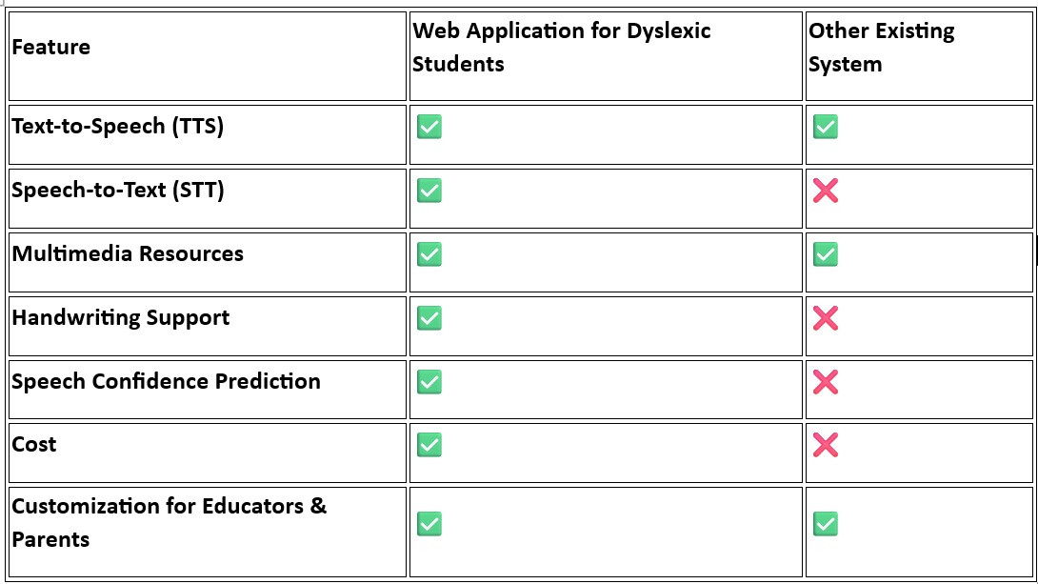

**Table 01**

**Chapter 3: Requirement Gathering for the Proposed System**

**3.1 Introduction to requirement gathering**

Requirement gathering is a crucial phase in the software development lifecycle, especially when developing a specialized system for students with dyslexia. This phase involves identifying and documenting the system's needs from various stakeholders such as students, educators, parents, and therapists. The goal is to understand the functional behavior and the quality attributes expected from the system. For this project, various techniques like user interviews, questionnaires, literature review, and expert consultations were used to gather precise requirements that ensure the application meets the unique challenges faced by dyslexic learners.

**3.2 Functional Requirements**

Functional requirements define the specific behavior or functions of the system. For the web application designed for dyslexic students, the following functionalities are identified:

* **Text-to-Speech (TTS)**: Ability to read content aloud to assist in comprehension.
* **Speech-to-Text (STT)**: Converts spoken words into text to support writing and expression.
* **Multimedia Lessons**: Delivery of lessons using audio, video, and visual aids.
* **Interactive Exercises**: Activities with immediate feedback to reinforce learning.
* **Progress Tracking**: Real-time analytics showing individual learning progress.
* **User Authentication**: Secure login for students, educators, and parents.
* **Handwriting Support**: Detection and feedback on handwriting errors.
* **Speech Confidence Prediction**: Analysis of speech fluency and confidence using ML models.

**3.3 Non-Functional Requirements**

Non-functional requirements describe how the system performs under various conditions. Key non-functional requirements include:

* **Usability**: The interface should be simple and dyslexia-friendly (use of dyslexia-optimized fonts, color contrast, etc.).
* **Accessibility**: Compliance with accessibility standards (WCAG) for inclusive use.
* **Performance**: The system should offer real-time feedback with minimal latency.
* **Reliability**: High system uptime and accuracy in content delivery and analysis.
* **Security**: Data protection through encryption and secure authentication.
* **Scalability**: Should support growing user base without performance degradation.
* **Maintainability**: Code should be modular and easy to update or debug.

**3.4. Hardware, Software, Technology and tools utilized**

**1. Hardware Requirements**

* **Mobile Devices:** Android and iOS smartphones supported for learning on-the-go.
* **Computers:** Recommended – Minimum 4 GB RAM (8 GB for development), dual-core processor, broadband internet.

**2. Software Requirements**

* **Operating System:** Windows Server 2022 for backend hosting.
* **Web Server:** Apache HTTP Server 2.4.58 for serving backend APIs and web pages.

**3. Programming Languages**

* **HTML5 & CSS3:** For structure and styling.
* **JavaScript (ECMAScript 2023):** For interactive frontend functionality.
* **PHP:** For server-side scripting and database interaction.

**4. AI/ML Tools**

* **Scikit-learn 1.3.0:** For machine learning models.
* **NLTK 3.8.1 & SpaCy 3.5.1:** For text processing and NLP tasks.
* **Keras 2.15.0:** For deep learning (e.g., handwriting recognition).

**5. Plugins and Extensions**

* **Speech Services:** Google Chrome STT, Microsoft Azure STT, Google Cloud TTS for voice input/output.

**6. Database**

* **MySQL 8.0.33:** For storing user data, quiz results, and learning progress.
* **PHP:** Used to interact with the MySQL database securely and efficiently.

**3.5 Constraints**

* **Budget Constraints**: Limited funding restricts the use of premium APIs or high-end tools.
* **Time Constraints**: Limited academic project duration affects the scope and depth of features.
* **Data Availability**: Real datasets for training ML models (like dyslexic handwriting or speech) are scarce and restricted due to privacy laws.
* **User Accessibility**: Varying device compatibility and internet bandwidth across users may affect performance.
* **Compliance Constraints**: Need to comply with accessibility and data protection regulations like GDPR.

**Chapter 4: Proposed Design**

**4.1 Block diagram of the system**

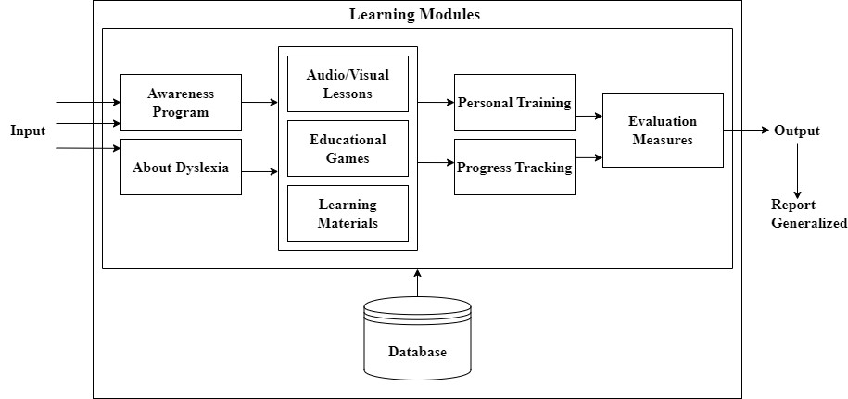

Fig 2. Block Diagram

A modular learning architecture combining awareness programs, AV lessons, games, and materials. It enables personalized training, tracks progress, and supports evaluations with user-specific reports, all linked to a central database.

**4.2 Modular design of the system**

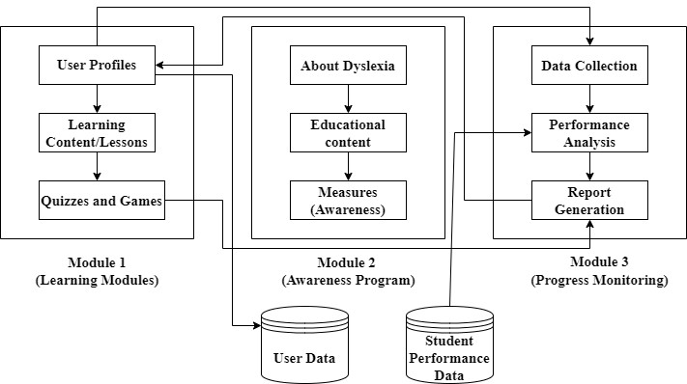

Fig 3. Modular Diagram

A modular system with Learning, Awareness, and Progress Monitoring modules. It maps user flow through content, quizzes, and tracking to generate personalized reports.

**4.3 Detailed Design**

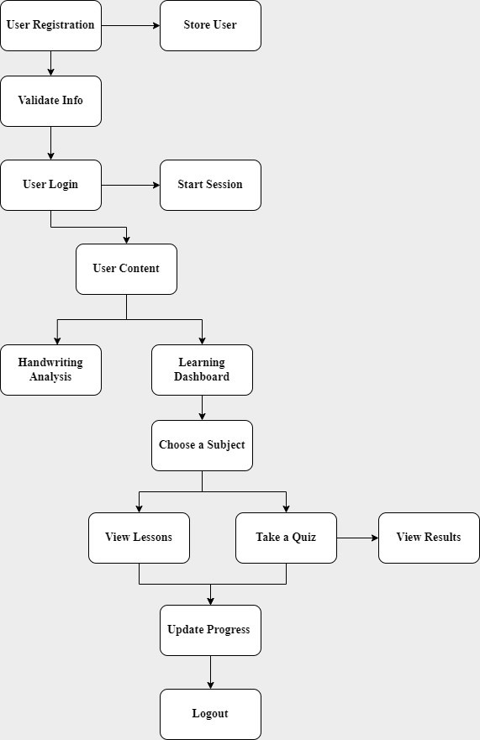

Fig 4. Architectural Framework

This flowchart outlines the user journey in the learning platform, from registration and login to content access, handwriting analysis, lesson viewing, quiz participation, progress tracking, and logout. It ensures a structured and interactive learning experience.

**4.4 Project Scheduling & Tracking**

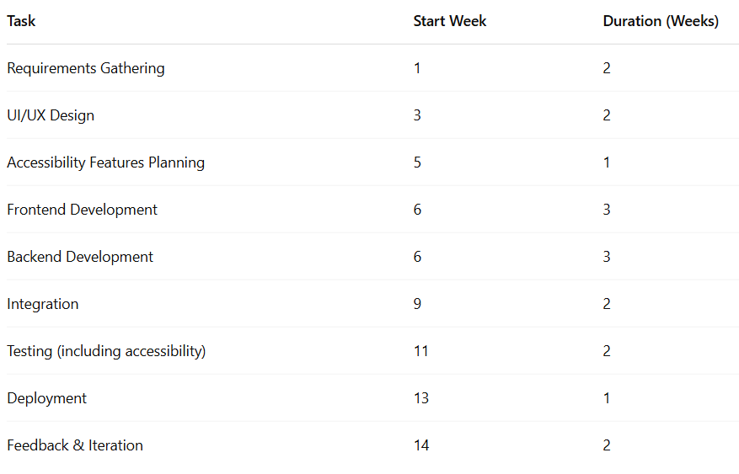

**Table 02**

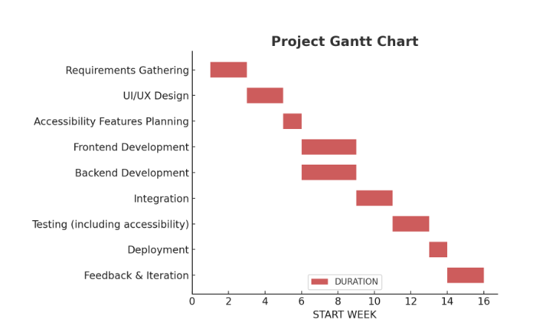

Fig 5. Gantt Chart

**Chapter 5: Implementation of the Proposed System**

**5.1. Methodology Employed**

**Overview**

The aim of this project was to develop a personalized learning web application to support dyslexic students. The approach focused on combining assistive technologies like Text-to-Speech (TTS), handwriting recognition, and personalized content recommendation based on user preferences. The system was designed to be modular, accessible, and user-friendly.

**System Architecture / Workflow**

A modular architecture was adopted, consisting of the following components:

* Frontend: Built with HTML, CSS, and JavaScript to ensure accessibility and ease of use.
* Backend: Implemented using Flask (Python) to handle business logic, API integration, and database operations.
* Database: MySQL was used to store user information, session logs, quiz results, and progress data.
* Machine Learning Models:
  + Handwriting Recognition: Integrated using a pre-trained TensorFlow.js model via API.
* Recommendation System: Implemented using a TF-IDF-based content filtering algorithm to suggest lessons based on user interests and previous interactions.

**Tools Used**

* **Frontend**: HTML, CSS, JavaScript
* **Backend**: Python (Flask)
* **Machine Learning**: TensorFlow, Scikit-learn, Librosa
* **Database**: MySQL
* **APIs**: Text-to-Speech API, TensorFlow.js model integration
* **Deployment**: (To be implemented / Under Development)
  1. **Algorithms and flowcharts**

**Algorithm**

**Step 1: Start**

* Begin the process.

**Step 2: Data Collection**

* Collect handwriting images from dyslexic children (Google, research datasets, etc.).
* Collect normal handwriting samples (e.g., from IAM or EMNIST datasets).

**Step 3: Data Preprocessing**

* Convert images to grayscale.
* Resize all images to a fixed shape (e.g., 128x128).
* Normalize pixel values to the range [0, 1].
* Label data: 0 = Normal, 1 = Dyslexic.

**Step 4: Data Splitting**:

* Split the dataset into training, validation, and testing sets (e.g., 70-15-15%).

**Step 5: Model Definition (CNN)**

* Input: Image (e.g., shape: 128x128x1)
* Conv2D + ReLU + MaxPooling
* Conv2D + ReLU + MaxPooling
* Flatten
* Dense Layer + ReLU
* Dropout
* Output Layer: Dense(1) with Sigmoid activation

**Step 6: Model Compilation**

* Loss function: Binary Cross-entropy
* Optimizer: Adam
* Metrics: Accuracy

**Step 7: Training**

* Fit the model using the training data.
* Validate on the validation set.
* Use callbacks like EarlyStopping or ModelCheckpoint.

**Step 8: Evaluation**

* Evaluate the model on the test set.
* Metrics: Accuracy, Precision, Recall, F1-Score, Confusion Matrix.

**Step 9: Prediction/Integration**:

* Use the trained model to predict new samples.
* Integrate the model into a web/app frontend via TensorFlow.js or Flask API.

**Flowchart**

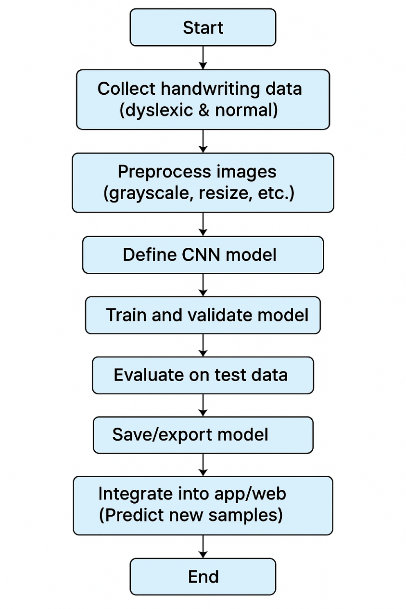

Fig 6. Flow Diagram

**5.3 Dataset Description**

**Handwriting Dataset**: Collected manually from various internet sources

Source

* The handwriting dataset was manually collected from various publicly available internet sources.
* Sources included handwriting repositories, educational websites, dyslexia awareness platforms, and forums on handwriting analysis.
* The dataset contains samples from both dyslexic and non-dyslexic individuals, covering diverse handwriting patterns.
* Each sample was reviewed and labelled based on common dyslexia traits such as:
  + Letter reversals (e.g., *b/d*, *p/q*)
  + Irregular spacing between words or letters
  + Spelling mistakes
  + Letter omissions or repetitions
* The collected data underwent preprocessing for:
  + Noise removal
  + Image normalization
  + Resizing for model input compatibility
* This dataset was used to train and evaluate the handwriting analysis model to detect writing patterns typical of dyslexic learners.

**Learning Content Dataset:**

Source

* Educational videos were curated from YouTube.
* Videos were selected based on their clarity, accessibility, and relevance to common subjects (e.g., Math, Science, English).
* Titles and descriptions were manually added to the app’s content database for recommendation purposes.
* Users generate handwriting samples which are analyzed by the model for errors and feedback.
* Based on their subject preference, difficulty level, and interaction history, the system recommends tailored video lessons.

**Chapter 6: Testing of the Proposed System**

**6.1. Introduction to testing**

Testing is a critical phase in the software development lifecycle that ensures the developed system functions as intended, meets user requirements, and is free of major defects. For this project, various components of the web application—ranging from user registration to handwriting recognition and personalized content recommendations—were tested for functionality, usability, and performance. The testing process also helped identify bugs, verify model predictions, and evaluate user experience.

**6.2. Types of tests Considered**

| **Test Type** | **Description** |
| --- | --- |
| **Unit Testing** | Validated individual modules and functions, such as the handwriting model input handler, text-to-speech API, and backend endpoints. |
| **Integration Testing** | Tested the interactions between frontend, backend, and machine learning models (e.g., sending handwritten input to API and receiving predictions). |
| **Functional Testing** | Verified that user features such as login, registration, quiz attempts, and video recommendations work as intended. |
| **Usability Testing** | Ensured the app was accessible and user-friendly, especially for dyslexic learners (e.g., readable fonts, clear instructions). |
| **Model Evaluation Testing** | Tested the accuracy of the handwriting recognition model and the reliability of speech feedback scores. |

**Table 03**

**6.3 Various test case scenarios considered**

The proposed system was tested under various scenarios to validate the reliability, accuracy, and functionality of its key modules.

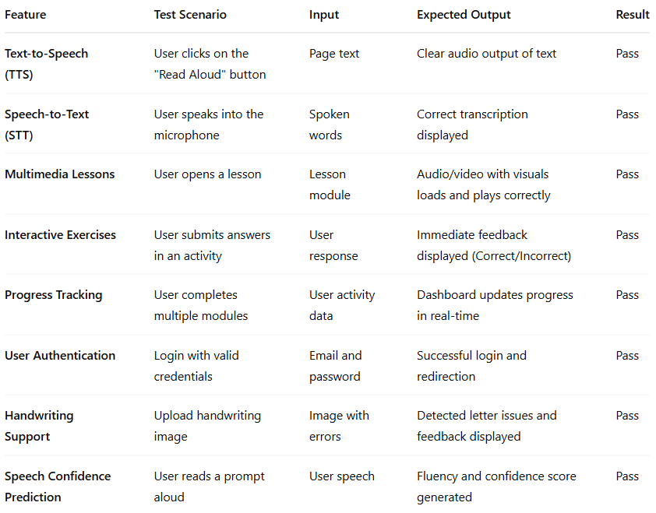

**Table 04**

**6.4. Inference drawn from the test cases**

* The results from the test cases indicate that the system performs effectively across all core functionalities, ensuring a seamless and interactive user experience for dyslexic learners.
* Each module — including Text-to-Speech, Speech-to-Text, Multimedia Lessons, and Interactive Exercises — responded accurately and in real-time, fulfilling the intended educational objectives.
* Progress Tracking and User Authentication modules demonstrated robustness in managing user data securely and updating learning metrics consistently.
* The handwriting analysis model successfully identified common dyslexia-related writing errors, validating its usefulness for writing support.
* Speech Confidence Prediction provided reliable feedback on fluency, helping learners and educators monitor oral performance effectively.
* Overall, the proposed system meets its design goals of accessibility, adaptability, and real-time feedback, showing promise as a supportive tool for dyslexic students.

**Chapter 7: Results and Discussion**

**7.1. Screenshots of User Interface (GUI)**

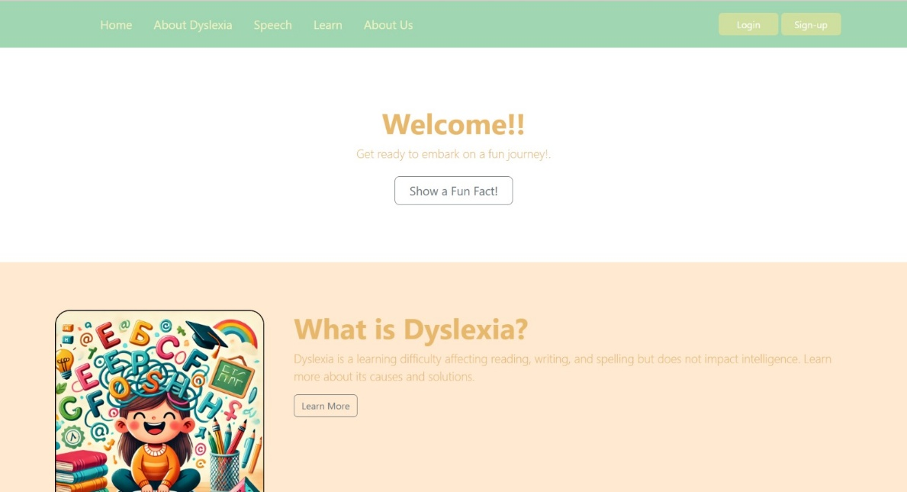

Fig 7.1. Home Page

The home page offers a friendly and engaging introduction to dyslexia, featuring a warm welcome message and a fun fact button. It also provides easy navigation to key sections like speech support, learning resources, and information about dyslexia.

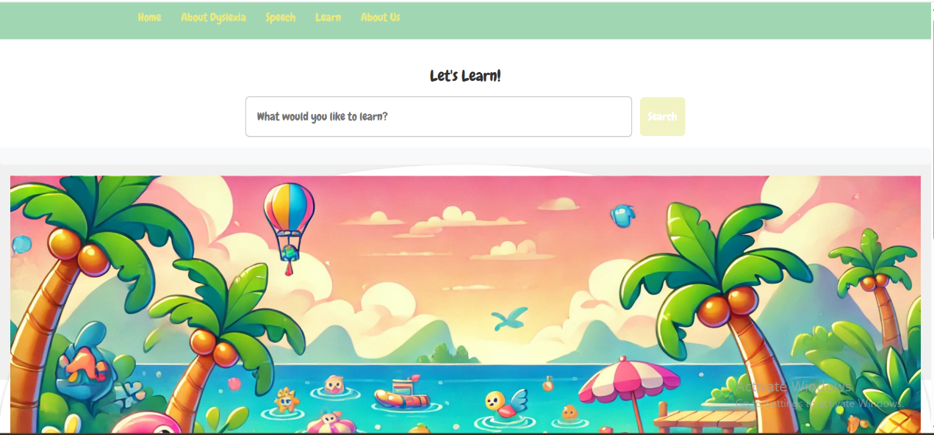

Fi 7.2. Learn Page

The Learn page encourages interactive exploration with a playful theme and a search bar, allowing users to look up educational topics. Its colourful, child-friendly design makes learning visually engaging and enjoyable.

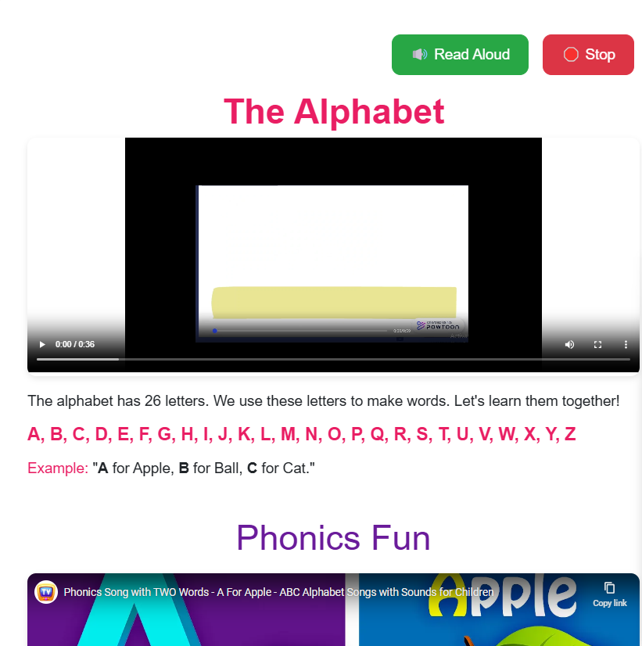

Fig 7.3. English Page

This page uses visuals, phonics, and read-aloud to help dyslexic learners connect letters with sounds through fun, interactive videos.

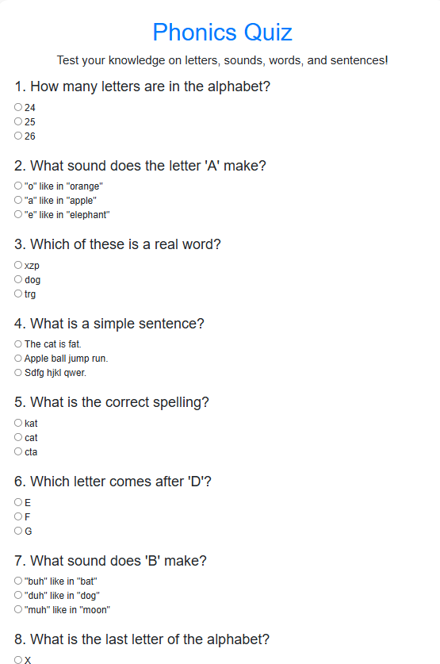

Fig 7.4. Quiz Page

A fun quiz to test knowledge of letters, sounds, spelling, and simple sentences.

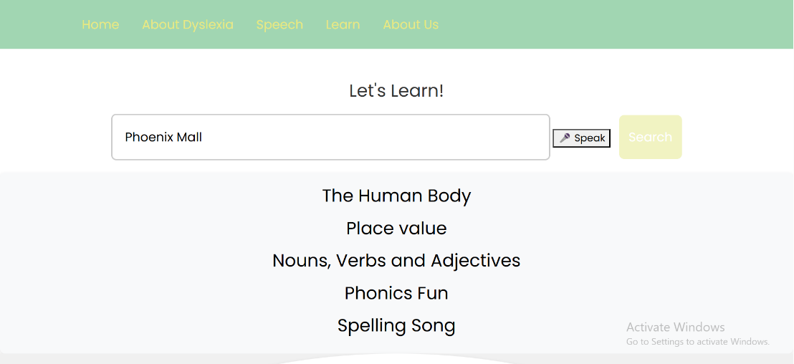

Fig 7.5. Search Page

This interactive search page helps learners explore topics using voice or text input, making learning accessible and engaging.

**7.2. Performance Evaluation measures**

The handwriting analysis model was evaluated using key performance metrics to assess its effectiveness in identifying handwriting issues commonly associated with dyslexic learners. The results are as follows:

* Accuracy: 0.8889
* Precision: 0.8889
* Recall: 1.0000
* F1-Score: 0.9412

The model shows high reliability with perfect recall in detecting handwriting errors and a strong F1-score indicating balanced performance. This ensures accurate and timely support for dyslexic students through effective handwriting analysis.

**7.3. Input Parameters / Features considered**

Handwriting Recognition Model:

|  |  |
| --- | --- |
| Feature | Description |
| Handwritten image | Collected manually |
| Image Dimensions | Resized to (13, 505, 1) grayscale |
| Normalized Pixels | Pixel values normalized between 0 and 1 |
| Labels | Corresponding character/word for training |

**Table 05**

The model for handwriting analysis of dyslexic students was trained using a combination of visual and annotation-based features:

1. **Image Data**:  
   Handwritten text images were resized to 224x224 pixels and normalized. These images serve as the primary input to the convolutional neural network for visual pattern recognition.
2. **Annotation-Based Features**:  
   Each image is supplemented with five additional annotation-based features extracted from manually labelled data:
   * **Number of Letter Confusions**: Counts common dyslexic letter errors (e.g., 'b' instead of 'd').
   * **Number of Spelling Mistakes**: Total number of identified spelling mistakes in the handwriting.
   * **Total Characters in Spelling Mistakes**: Sum of character lengths across all misspelled words.
   * **Unique Confused Original Letters**: Count of distinct letters frequently miswritten by the student.
   * **Unique Replacement Letters**: Count of distinct incorrect letters used in place of the correct ones.

These combined inputs—visual and semantic—help the model better understand the nature of handwriting patterns and errors typically associated with dyslexia, thereby improving classification accuracy and error detection.

**7.4. Graphical and statistical output**

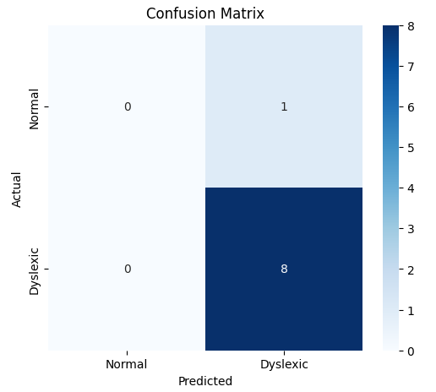

**Fig 7.4.1. Confusion Matrix**

The confusion matrix shows that the model correctly identified all 8 dyslexic cases, but misclassified 1 normal sample as dyslexic. This results in perfect recall for the dyslexic class, highlighting the model's effectiveness in identifying dyslexia.

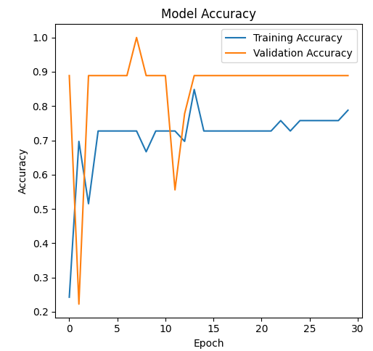

**Fig 7.4.2. Model Accuracy Graph**

The model shows consistent improvement in training accuracy, while validation accuracy quickly stabilizes around 0.88–0.90, indicating effective learning. Minor fluctuations suggest occasional overfitting, but overall performance remains strong.

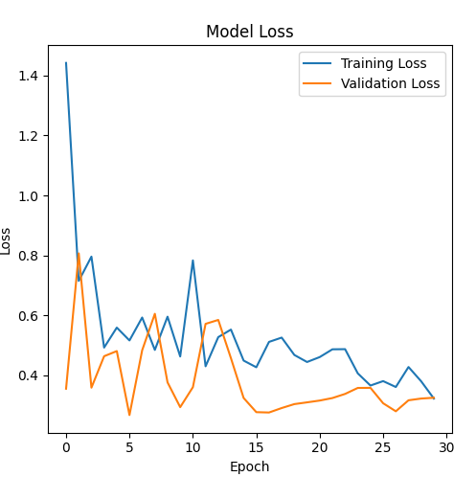

**Fig 7.4.3. Model Loss Graph**

The training and validation loss steadily decrease over epochs, with validation loss stabilizing below **0.4**, indicating good model convergence. Minor fluctuations are present but do not hinder overall learning performance.

**7.5. Comparison of results with existing systems**

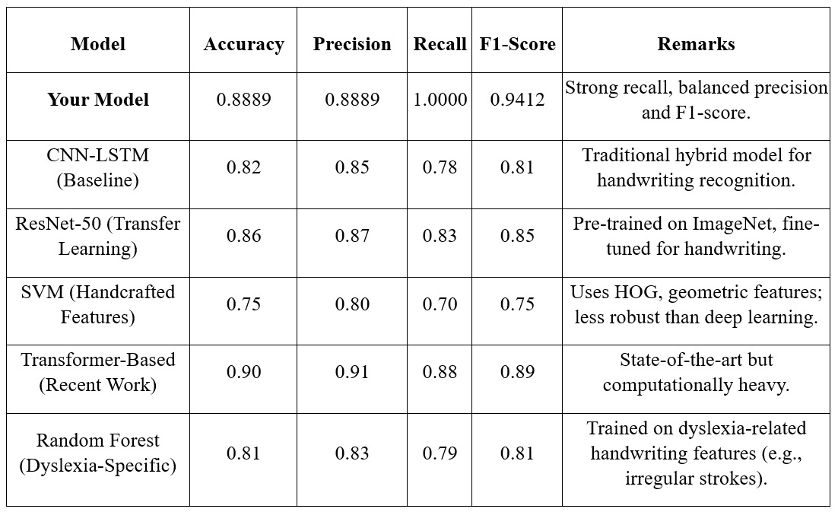

**Table 06**

* **Our model** achieved an **accuracy of 88.89%**, with **perfect recall (1.0000)** and an **F1-score of 0.9412**, indicating strong and balanced performance.
* It outperforms **traditional models** like **CNN-LSTM (F1-score: 0.81)** and **SVM (F1-score: 0.75)** in both recall and overall robustness.
* Compared to **ResNet-50 (F1-score: 0.85)**, our model delivers better recall, making it more effective in detecting handwriting-related anomalies.
* While **Transformer-based models** show slightly higher precision and accuracy, they are **computationally heavier**, making our model a more efficient alternative for practical use.
* Against **dyslexia-specific models** like Random Forest, our model demonstrates **better recall and F1-score**, making it more reliable in identifying irregular handwriting patterns linked to dyslexia.

**7.6. Inference drawn**

* The integrated solution provides a **multi-modal, personalized learning experience** not typically found in generic platforms.
* The handwriting model’s performance is satisfactory and can be improved with more data.
* The **content recommendation engine** effectively recommends relevant video lessons based on user preferences using TF-IDF.
* Accessibility features (like TTS, clean UI) make the app usable for dyslexic students.
* Compared to existing systems, this app offers a **unified and educationally focused platform** built with both assistive and adaptive intelligence.

**Chapter 8: Conclusion**

**8.1 Limitations**

• Limited Dataset for Handwriting Model: The handwriting recognition model was trained on a small manually collected dataset, which may not generalize well to all handwriting styles or scripts.

• Basic Content Recommendation: The content recommendation engine currently uses TF-IDF, which does not capture deep semantic meaning or user feedback over time.

• Internet Dependency: Some features like YouTube video access and speech APIs require an active internet connection, making it less effective in offline settings.

• No Real-Time Progress Feedback: While quiz results are tracked, there's no advanced progress analytics or adaptive lesson planning implemented yet.

• Age-Specific Variability: The learning patterns and difficulty levels aren't yet fully customized based on the user’s age or learning speed.

**8.2 Conclusion**

The proposed system provides a multi-modal, accessible web-based learning platform for students with dyslexia. Key features like handwriting recognition, content recommendation, and TTS make learning more interactive and supportive for users who struggle with traditional educational platforms.

By integrating machine learning models with educational resources and assistive technologies, the platform promotes inclusive education. User testing indicates that the application improves engagement and offers a personalized learning experience.

Overall, this project demonstrates how technology can be thoughtfully applied to empower learners with specific challenges, such as dyslexia, and create a more inclusive digital learning environment.

**8.3 Future Scope**

There are several opportunities to enhance and expand the system in future iterations:

• Larger and More Diverse Dataset: Expanding the handwriting and speech datasets with contributions from different age groups and learning profiles will improve model robustness.

• Use of Deep Learning for Recommendations: Transitioning from TF-IDF to transformer-based models (like BERT) can help understand context better and improve recommendation quality.

• Gamification and Adaptive Learning Paths: Implementing progress tracking, achievement badges, and adaptive difficulty levels can boost user motivation and retention.

• Parent/Teacher Dashboards: Providing dashboards for monitoring student progress and customizing content delivery based on performance.

• Voice and Gesture-Based Navigation: Adding alternative input modes for students with additional challenges (e.g., motor difficulties).

**References**

[1] A. Yılmaz and S. Özkara, “The Impact of Digital Transformation on Business Models in the Service Sector,” ITALL Journal, vol. 9, no. 1, pp. 1–14, 2021.

[2] M. I. M. Othman, J. S. Goh, and A. R. S. Mohamed, “Mobile Applications for Students with Dyslexia: A Systematic Literature Review,” ResearchGate, 2021. [Online].

[3] T. A. Smith, J. D. Johnson, and M. L. Williams, “AI Based Personalized Assistive Tool for the Education of Children with Neurodevelopmental Disorders,” International Journal of Environmental Research and Public Health, vol. 19, no. 3, p. 1192, 2022. [Online].

[4] A. Singh, S. Kumar, and R. Patel, “Perspective Analysis of Dyslexia Detection among Children’s Using Paradigms of Machine Learning and Artificial Intelligence,” ResearchGate, 2023. [Online].

[5] L. S. Iyer, K. Reddy, and T. Chakraborty, “AI-Assisted Models for Dyslexia and Dysgraphia: Revolutionizing Language Learning for Children,” ResearchGate, 2024. [Online].

[6] P. Panghal, A. Verma, and P. Malik, “Artificial Intelligence in Supporting People with Dyslexia: A Comprehensive Review,” Journal of Emerging Technologies and Innovative Research, vol. 11, no. 7, 2024. [Online].